Name:_________________

Date:__________________

**Warm up 3.2 SHOW YOUR WORK!!!**

1. Graph the exponential equation. Then state the inverse function in logarithmic form and graph it. Then state the domain and range of each function.

$y={\left(\frac{1}{2}\right)}^{x}$ Inverse:_______________________

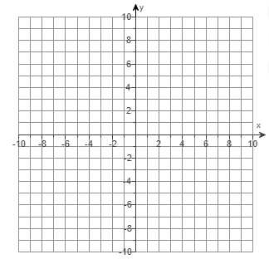

Domain:____________________ Domain:___________________________

Range:_____________________ Range:____________________________

2. Evaluate the following logarithms without using a calculator. Write your answer as either an integer or a fraction.

3. Without using a calculator, which of the following is greater? Explain how you know using complete sentences:

or

4. Write the following exponentials in logarithmic form:

5. Evaluate or simplify the expressions below without using a calculator.

$e^{\ln\left(100\right) }$ $\ln{e^{5y}}$ $\log_{7}{(\log{10)}}$